SolutionTool User Guide

Running with a Real Repository

# Download User Guide and Install SolutionTool

Before running with any real repository, please take a look at the SolutionTool User Guide document, which include the content of customizing file structure template, specifying InspecCode executable path, creating new projects and running checks on projects. The document is available at:

<https://github.com/paytonli2013/SolutionTool/tree/master/Doc>

SolutionTool (v1.0.0.0) is shipped as an msi file that can be downloaded at:

<https://github.com/paytonli2013/SolutionTool/tree/master/Deployment>

# Running SolutionTool on the SolutionTool Git repository

## Map SolutionTool Git Repository to Local Folder

As you can see from below screenshot, I’ve mapped our Git project <https://github.com/paytonli2013/SolutionTool> to F:\_E_\SolutionTool on my local machine.

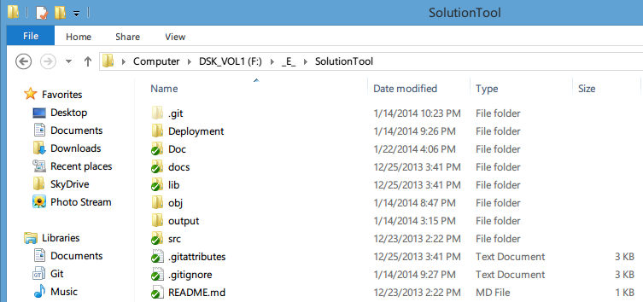

## Start SolutionTool.exe to Run Checks and View Reports

### Customize File Structure Template using a GitIgnore-like Pattern

Please select the Templates node before you edit the details.

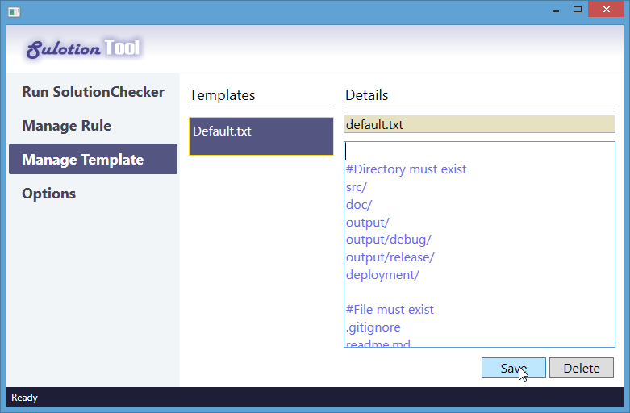

### Specify Executable Path to InspectCode

Please select the Setting node before you fill in the details area.

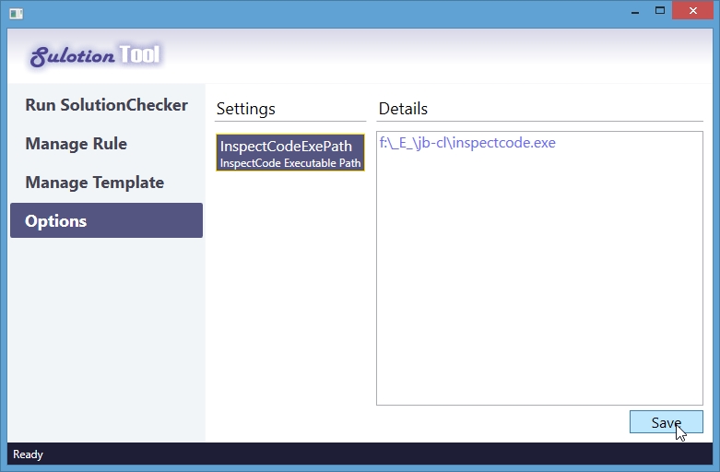

### Create a New Project by Select Target Folder of our Local Git Repository

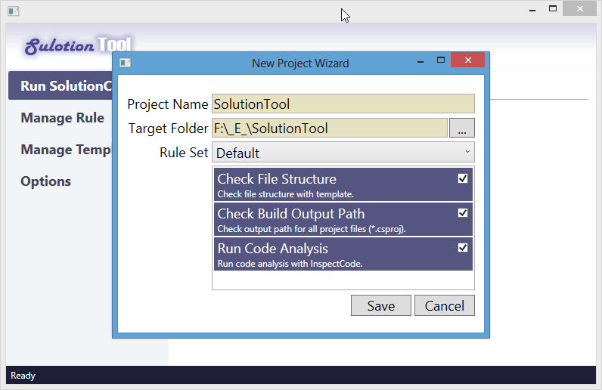

### Run Checks on the Project

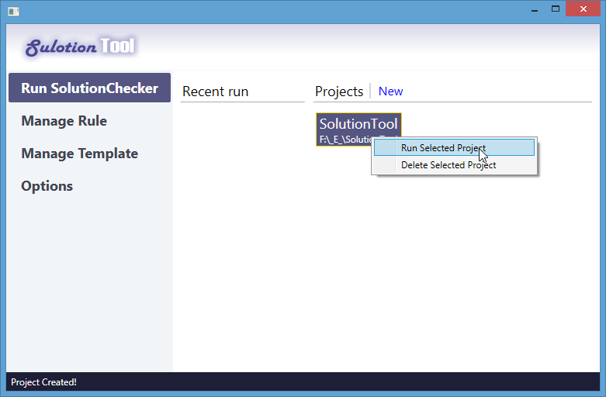

InspectCode is lauched if the specified path is correct.

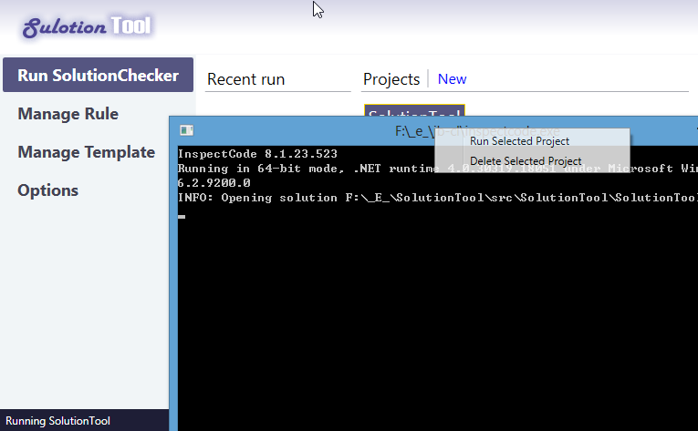

InspectCode is checking code and generating reports.

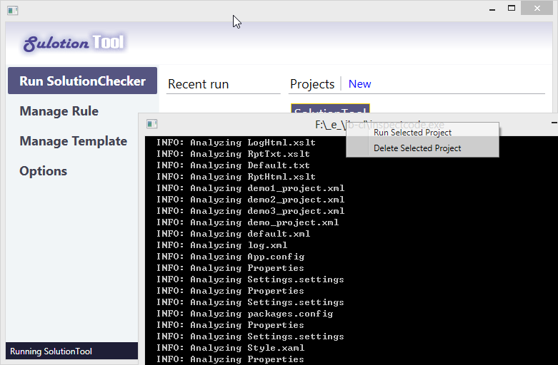

### Report Viewer popup after checks are done.

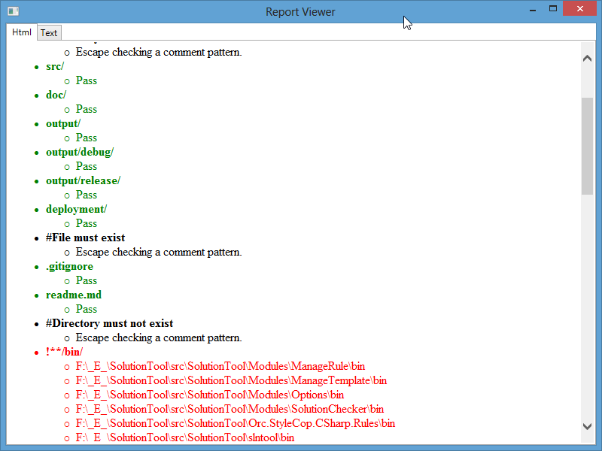

### InspectCode Report link is integrated at the end of the report.

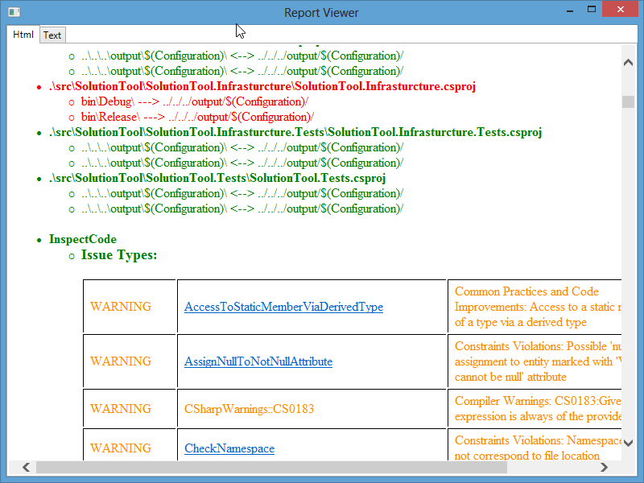

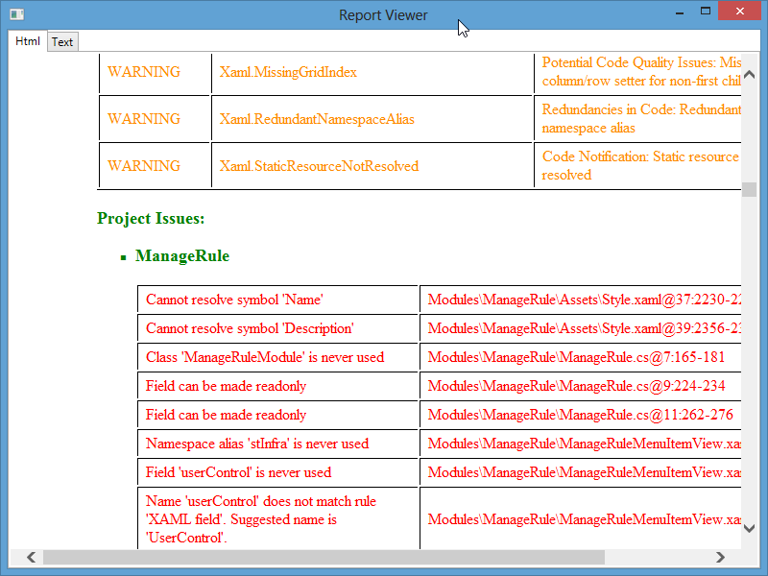

### Recent Run is Logged.

